

**AI-Powered Health Assistant**

A Project Report

submitted in partial fulfillment of the requirements of

AICTE Internship on AI: Transformative Learning with

TechSaksham – A joint CSR initiative of Microsoft & SAP

by

**Srikeerthipriya Shankar**

[**srikeerthipriya1998@gmail.com**](mailto:srikeerthipriya1998@gmail.com)

Under the Guidance of

**Aditya Prashant Ardak**



### ACKNOWLEDGEMENT

I am deeply grateful to all those who supported me during this project. Special thanks are extended to my guide, **Aditya Prashant Ardak**, for the continuous guidance and insightful suggestions. Extremely thankful to Adarsh P Sir who had helped me gain lot of clarity with various concepts related to the project. I also appreciate my peers, family, and the entire team at **TechSaksham** of **edunet foundation** for providing such an enriching platform to explore and implement innovative ideas in the field of artificial intelligence. Their expertise and constructive feedback were invaluable in overcoming challenges and refining the project.

I deeply appreciate the vision of TechSaksham which offered me transformative learning experience and access to invaluable resources which have significantly enhanced my technical knowledge and professional development.



### ABSTRACT

This project report details the development of an AI-powered Healthcare Assistant Chatbot designed to provide users with instantaneous and accurate responses to healthcare-related queries. The system integrates state-of-the-art Natural Language Processing (NLP) techniques with machine learning models, specifically employing the Hugging Face transformer model 'distilgpt2' for text generation. Developed as a Streamlit web application, the chatbot offers an interactive user interface and processes queries in real-time. This report encompasses the motivation behind the project, a comprehensive literature review, the proposed methodology, detailed implementation, and an in-depth discussion on results, limitations, and potential future enhancements. The primary objective is to alleviate the burden on healthcare professionals by providing preliminary advice and guidance, while ensuring that users are directed to seek professional help when necessary.

.

**TABLE OF CONTENT**



Abstract 3

Chapter 1. Introduction 6

* 1. Problem Statement 6
  2. Motivation 6
  3. Objectives 7
  4. Scope of the Project 7

Chapter 2. Literature Survey 8

* 1. Review relevant literature 8
  2. Existing Models, Techniques, and Methodologies 9
  3. Limitations in Existing Systems 10

Chapter 3. Proposed Methodology 11

* 1. System Design 11
  2. Requirement Specification 11

Chapter 4. Implementation and Results 14

* 1. Snap Shots of Result 14
  2. GitHub Link for Code 16

Chapter 5. Discussion and Conclusion 17

* 1. Future Work 17
  2. Conclusion 18

References 19



**LIST OF FIGURES**

|  |  |  |
| --- | --- | --- |
| **Figure No.** | **Figure Caption** | **Page No.** |
| **Figure 1** | System Workflow for AI-Powered Chat Assistant | **12** |
| **Figure 2** | Overall Workflow of AI-Powered Chat Assistant. | **13** |
| **Figure 3** | Snapshot of the Streamlit Interface. | **14** |
| **Figure 4** | Snapshot of Streamlit Interface where user can type is/her query. | **14** |
| **Figure 5 & 6** | Snapshot of AI-Powered Assistant’s response | **15,16** |

# CHAPTER 1



## Introduction

In the contemporary digital era, artificial intelligence has emerged as a transformative force across various sectors, including healthcare. The growing need for efficient, reliable, and easily accessible medical information has spurred the development of AI-driven healthcare solutions. This project focuses on the creation of an AI-powered Healthcare Assistant Chatbot that leverages advanced NLP techniques and machine learning algorithms to assist users with health-related queries. The chatbot is designed to provide immediate, contextually relevant responses, thereby serving as a preliminary resource for users seeking medical advice, appointment scheduling, medication information, and general wellness tips.

#### Problem Statement:

Traditional healthcare systems often face challenges such as long waiting times, limited accessibility, and information overload. Patients may struggle to find accurate information promptly, leading to delays in obtaining necessary medical care. The lack of an efficient system to pre-screen and provide initial guidance exacerbates these issues. The primary problem addressed in this project is the need for an intelligent, user-friendly platform that can effectively bridge the gap between patients and healthcare providers by offering instant assistance and guidance through AI-driven conversations.

#### Motivation:

The motivation behind developing the AI-powered Healthcare Assistant Chatbot stems from the imperative to enhance patient engagement and streamline the initial healthcare consultation process. With the increasing demand for digital health solutions, especially in remote and underserved regions, this project aims to democratize access to basic healthcare information. By integrating machine learning and NLP, the chatbot is capable of understanding natural language inputs and generating responses that are both accurate and empathetic. This initiative is driven by the vision to support healthcare professionals by reducing their burden and enabling them to focus on critical cases, while also providing patients with a reliable first point of contact.

#### Objectives:



The primary objectives of the project include:  
 - Developing an interactive chatbot capable of processing and responding to healthcare-related queries in real-time.  
 - Integrating advanced NLP techniques using pre-trained models to enhance the accuracy of responses.  
 - Implementing a user-friendly interface using Streamlit to ensure ease of use and accessibility.  
 - Ensuring the system can handle a variety of health-related topics such as symptoms, appointments, medication advice, and lifestyle recommendations.  
 - Evaluating the performance of the chatbot through rigorous testing and user feedback.

#### Scope of the Project:

##### Scope:

The scope of this project is confined to the development of a chatbot that provides general healthcare assistance. It does not replace professional medical advice but rather serves as an initial support tool. The system is designed for small to medium-scale deployment, particularly in scenarios where immediate access to basic health information is critical. The chatbot's functionalities are optimized for common healthcare queries, and while it addresses a broad range of topics, highly specialized medical consultations remain outside the scope of this project.

# CHAPTER 2



## Literature Survey

##### The advent of artificial intelligence has revolutionized numerous industries, with healthcare being one of the most significantly impacted sectors. The application of AI in healthcare has ranged from diagnostic imaging to predictive analytics and virtual health assistants. This section provides a review of the existing literature pertinent to AI-powered chatbot in healthcare.

##### 2.1 Review of AI in Healthcare:

##### Recent studies have demonstrated the potential of AI to transform patient care by enabling rapid access to medical information, personalized recommendations, and decision support. AI-powered chatbots have been deployed in various healthcare settings to assist with symptom checking, appointment scheduling, and patient triage. The effectiveness of these systems largely depends on the underlying NLP algorithms and the quality of the training data.

##### 2.2 Natural Language Processing Techniques:

##### NLP is a critical component in developing conversational agents. Techniques such as tokenization, stopword removal, and language modeling are fundamental to understanding and generating human-like text. Pre-trained transformer models, such as GPT-2 and its distilled versions, have shown remarkable performance in text generation tasks. These models are fine-tuned on domain-specific datasets to improve their relevance and accuracy in specialized fields like healthcare.

##### 2.3 Existing Healthcare Chatbots:

##### Several healthcare chatbots have been developed and deployed, each with its unique set of features and limitations. For instance, Babylon Health and Ada Health provide symptom assessment and medical advice using AI algorithms. However, challenges remain in ensuring the accuracy of responses, handling ambiguous queries, and maintaining user trust. Limitations such as data privacy concerns and the inability to handle complex medical cases highlight the need for continuous improvement in these systems.

Med-Bot is an AI-powered chatbot designed to provide accurate and reliable medical information by integrating advanced natural language processing and data processing frameworks. [1] It leverages technologies such as PyTorch for deep learning, Chromadb for data management, Langchain for context-based language processing, and AutoGPT-Q for extracting insights from medical literature. Enhanced by llama-assisted data processing, Med-Bot interprets complex medical queries to deliver precise, context-aware responses that improve the accessibility and quality of healthcare information for users.

From Stress to Support: An AI-Powered Chatbot for Student Mental Health Care  
This paper presents an AI-powered chatbot aimed at addressing the mental health challenges faced by students [2] —such as anxiety, depression, and stress—by providing scalable and accessible support. By integrating natural language processing, machine learning, and digital health technologies, the system delivers personalized interventions through surveys, questionnaires, and case studies. The chatbot not only reduces stigma and encourages early intervention but also complements traditional mental health services in educational settings, offering an innovative solution for student well-being.

Personalized Daily Life Improvement and Intellectual Health Guidance  
This paper introduces a novel, NLP-powered chatbot [3] designed to enhance daily life and intellectual health by analyzing users’ daily journal entries. The system applies tokenization, sentiment analysis, and feature extraction to identify emotional patterns and recurring themes in personal writings. Based on this analysis, it generates personalized recommendations—ranging from time management and stress reduction strategies to self-care activities—aimed at mitigating anxiety and fostering continuous self-improvement. The approach offers an accessible, privacy-preserving solution that promotes early intervention and proactive mental health management.

In "The Rise of the Mental Health Chatbot," the chapter explores how AI-powered chatbots are emerging as transformative tools in mental health care by bridging treatment gaps and providing accessible, [4] real-time support for conditions such as depression and anxiety. Through a review of multiple case studies, the work highlights measurable benefits including enhanced patient engagement, personalized interventions, and scalable service delivery. It also addresses key challenges—such as ensuring reliability, ethical integration, and user acceptance—emphasizing the need for ongoing research to refine these digital solutions in healthcare.

This paper addresses the growing mental health concerns among students—such as depression, anxiety, and stress—who often refrain from seeking professional help due to financial or personal barriers. The authors propose “CareBot,” [5] a chatbot designed to offer counselor-like support by leveraging machine learning, data analysis, and natural language processing (NLP). By incorporating surveys, questionnaires, and the use of GPT (Generative Pre-trained Transformer) models, CareBot provides personalized interactions and mental health assistance through an online platform, thereby reducing stigma and facilitating early intervention and continuous support.

This paper presents a usability evaluation of a chatbot designed to provide personalized fitness and health recommendations for older adults in assisted healthcare settings. Through user studies involving seniors, [6] the research assesses the chatbot's effectiveness in delivering tailored exercise routines, nutrition tips, and wellness guidance. Preliminary findings indicate that the interface is generally user-friendly and that many seniors appreciate the immediate, customized advice. However, concerns about data privacy, personalization accuracy, and technology adoption among less tech-savvy users remain, suggesting the need for further refinements to maximize long-term engagement.

**2.4** **Addressing existing** **gaps**:  
While the existing literature provides a solid foundation, there are gaps that this project aims to address. Most notably, there is a need for a more user-friendly interface that leverages the latest advancements in NLP to offer more accurate and contextually appropriate responses. Furthermore, integrating these systems with real-time web applications remains a challenge. This project seeks to fill these gaps by developing a robust, interactive chatbot using Streamlit and state-of-the-art NLP models



# CHAPTER 3



## Proposed Methodology

This chapter outlines the methodology employed in developing the AI-powered Healthcare Assistant Chatbot. The system is designed with a modular approach, ensuring that each component is optimized for performance and scalability. The methodology encompasses the overall system architecture, requirement specifications, and the integration of various technologies.  
  
**3.1 System Architecture**:  
The system architecture is divided into four main modules:

a) **User Interface (UI) Module**: Developed using Streamlit, this module provides an interactive web-based interface for users to input their queries and view responses. The design prioritizes simplicity and accessibility.

b) **Natural Language Processing (NLP)** Module: Utilizing NLTK, this module preprocesses user inputs by tokenizing text and removing stopwords. This ensures that the input is normalized before being processed by the AI model.

c) **AI Response Generation Module**: The core of the system, this module employs the 'distilgpt2' transformer model from Hugging Face to generate responses. The model is fine-tuned to address healthcare-related queries and is capable of generating coherent, contextually relevant text.

**d) Backend Processing Module**: This module handles the communication between the UI and the AI model, managing API calls, processing delays, and error handling.

**3.2 Requirement Specification:**  
**Hardware Requirements:**  
 - A modern PC or server with a multi-core processor and at least 8GB of RAM.  
 - A stable internet connection for accessing pre-trained models and libraries.  
  
**Software Requirements:**  
 - Operating System: Windows/Linux/MacOS

Visual Studio  
 - Python 3.x  
 - Libraries: Streamlit, Transformers, NLTK, and additional dependencies for data processing.

**3.3 Detailed Workflow**:

**1. User Query Input:** The user enters a query via the Streamlit interface. The input is then sent to the NLP module for preprocessing.  
 **2. Text Preprocessing:** NLTK processes the input by converting it to lowercase, tokenizing the words, and removing stopwords. This ensures that extraneous information is minimized and only the essential elements of the query are retained.  
 **3. Response Generation:** The processed text is passed to the 'distilgpt2' model, which generates a relevant response based on its training data. The model leverages contextual cues from the input to produce a coherent and contextually appropriate answer.  
 **4. Displaying the Response:** The generated response is sent back to the Streamlit interface, where it is displayed to the user in real-time.

**3.4 Integration with Streamlit:**  
Streamlit is utilized to create a responsive and interactive web application. Its simplicity allows for rapid prototyping and seamless deployment of the chatbot. The framework supports real-time updates, ensuring that the user's experience is smooth and engaging. The integration also includes error handling mechanisms to manage unexpected inputs or processing delays.

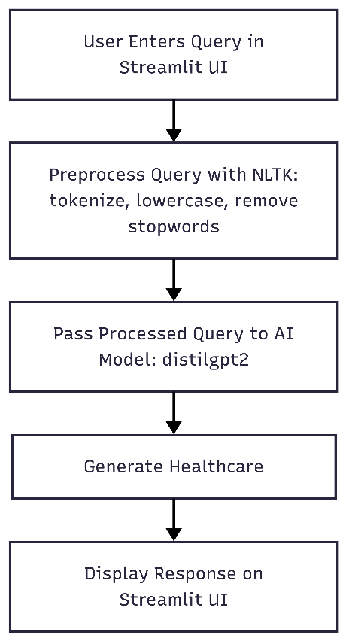

**Figure 1**: System Workflow of AI-Powered Chat Assistant



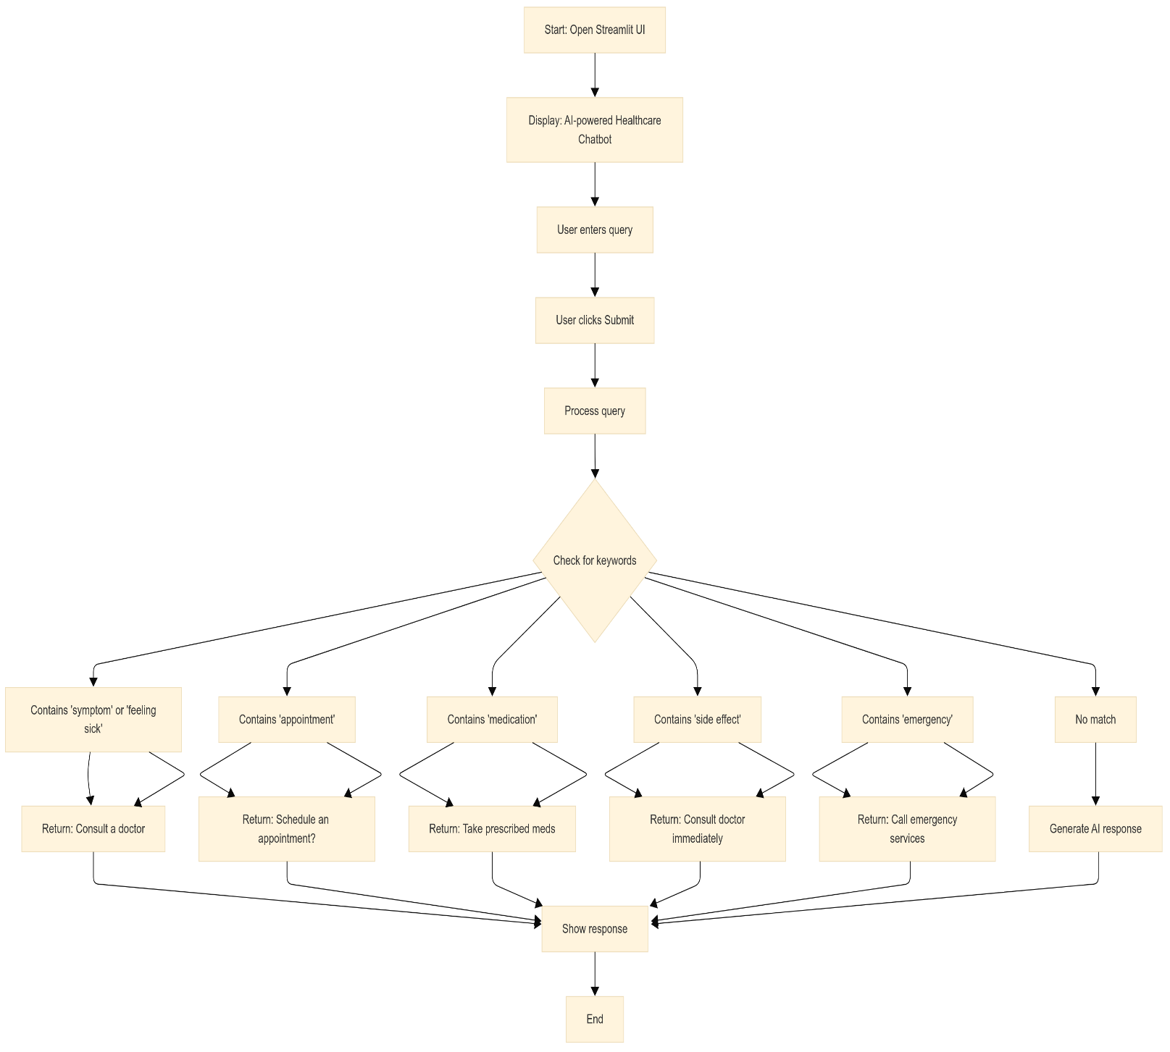

**Figure 2**: Overall Workflow of AI-Powered Chat Assistant

# CHAPTER 4



## Implementation and Result

#### Snap Shots of Result:

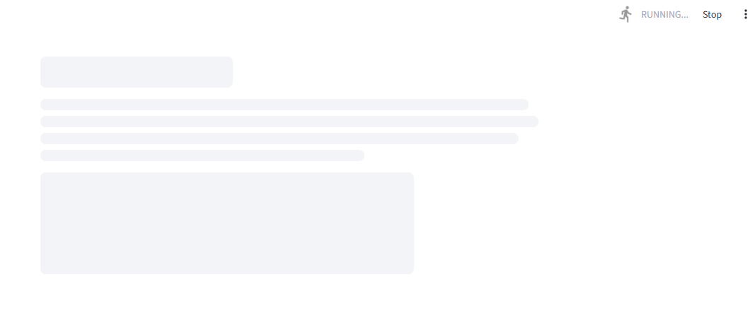

**Figure 3: Snapshot of Streamlit Interface**

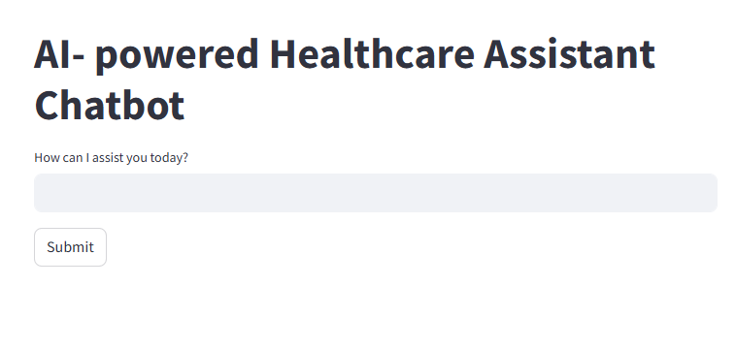

**Figure 4:** Snapshot of Streamlit Interface where user can type is/her query.

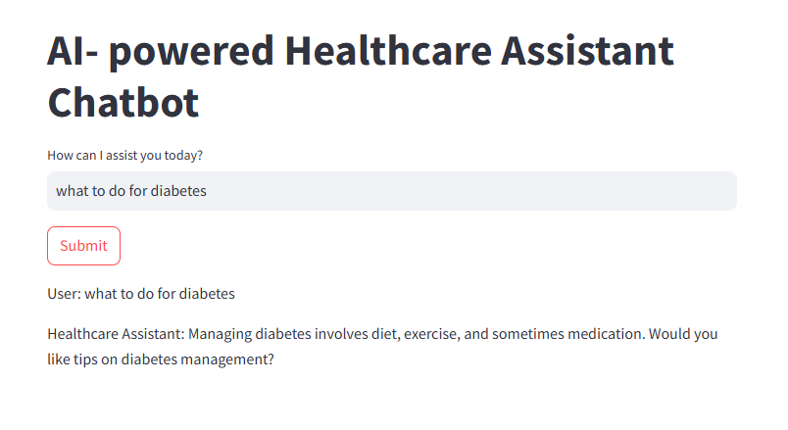

|  |  |
| --- | --- |
| **Figure 5** | Snapshot of AI-Powered Assistant’s response |



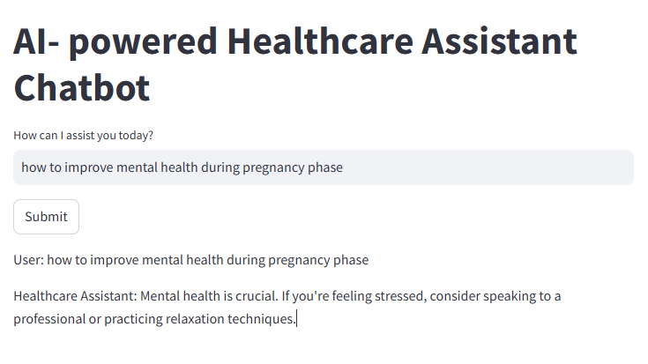

|  |  |
| --- | --- |
| **Figure 6** | Snapshot of AI-Powered Assistant’s response |

**4.2 GitHub Link for Code:**

https://github.com/Srikeerthi2401/Data-Science/blob/main/app1%20(1)%20(1).py

# CHAPTER 5



## Discussion and Conclusion

##### The development of the AI-powered Healthcare Assistant Chatbot has demonstrated the significant potential of combining advanced NLP techniques with a user-friendly web interface to enhance healthcare accessibility. This project has successfully created a platform that offers immediate, contextually relevant responses to a wide range of health-related queries. The integration of the 'distilgpt2' model has enabled the chatbot to generate natural and coherent text, while the use of Streamlit ensures an interactive and responsive user experience. 5.1 Future Work: While the current implementation is robust, there are several avenues for future improvement: - *Enhanced Model Training*: Further fine-tuning the transformer model on a larger, more diverse healthcare dataset can improve response accuracy. - *Voice-based Interaction:* Integrating voice recognition and synthesis could make the chatbot more accessible, particularly for users with disabilities. - *Multilingual Support*: Expanding the chatbot's capabilities to support multiple languages will broaden its reach to a global audience. - *Integration with Health Records*: Connecting the chatbot with electronic health records (EHR) systems can provide personalized advice based on user history, while maintaining strict data privacy protocols. - *Mobile Application*: Developing a mobile version of the chatbot would enhance accessibility and convenience for users on the go.

#### 5.2 Conclusion:



In conclusion, the AI-powered Healthcare Assistant Chatbot represents a significant step towards the democratization of healthcare information. By leveraging state-of-the-art NLP models and a robust web framework, this project has created a tool that not only provides quick responses to healthcare queries but also serves as a bridge between patients and professional medical advice. The success of this project underscores the transformative potential of AI in the healthcare sector, and sets the stage for further innovations aimed at improving patient care and accessibility.

The intuitive user interface, built using Streamlit, ensures accessibility for a wide range of users, from administrators to end-users.

This project lays a strong foundation for future improvements, including:

* + 1. **Scalability:** Enhancing the system to handle more queries simultaneously with cloud-based storage and processing.
    2. **Improved User Experience:** Upgrading the interface for a more modern, dynamic, and user-friendly experience.
    3. **Data Privacy and Security:** Ensuring the system adheres to strict privacy standards with robust encryption and secure storage mechanisms.

By addressing limitations and expanding functionalities, this project has the potential to evolve into a comprehensive AI-powered health assistant which helps people seek basic medical advice at the very first instance; immediately.

# References

|  |  |
| --- | --- |
| [1] | A. Bhatt and N. Vaghela, "Med-Bot: An AI Powered Assistant to Provide Accurate and Reliable Medical Information," *Indus Universityy.* |
| [2] | N. Umashankar and K. Geethanjali, "From Stress to Support: An AI-Powered Chatbot for Student Mental Health Care," 2021. |
| [3] | J. Kaur, Aastha, Sandhiya and S. Kumari, "Personalized Daily Life Improvement and Intellectual Health Guidance," *IRJCS,* vol. 11, no. 4, pp. 167-170, Apr 2024. |
| [4] | M. Rauws, N. Lidstromer, H. Ashrafian and E. Cham, "The Rise of the Mental Health Chatbot in Artificial Intelligence in Medicine," in *Springer*, Switzerland, 2021. |
| [5] | R. Crasto, L. Dias, D. Miranda and D. Kayande, "CareBot: A Mental Health ChatBot," *" in 2021 2nd International Conference for Emerging Technology (INCET),* p. 1–5, 2021. |
| [6] | W. Pillay, Q. Gao, A. Hein and S. Fudickar, "Usability Evaluation of a Chatbot for Fitness and Health Recommendations Among Seniors in Assisted Healthcare," in *International Joint Conference on Biomedical Engineering Systems and Technologies*, Portugal, 2025. |